P E A K S

A competitive engine-building game of hiking and mountaineering for 2-6 players.

Designed by Sam Gray

In Peaks, you are aspiring mountaineers, beginning the game hiking up iconic hills from around the world as you build your stamina and experience. You will gather equipment and meet companions to assist you in climbing the world’s tallest mountains!

Components

1 game board

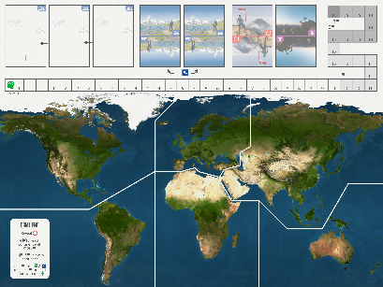

97 mountain cards

18 companion cards

18 bonus cards

6 player mats

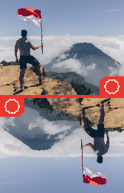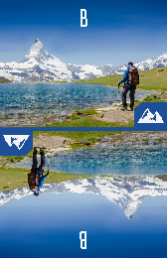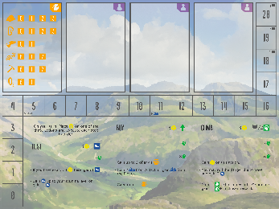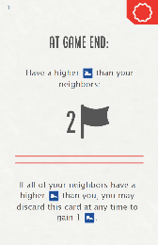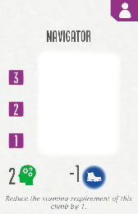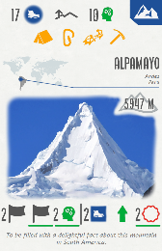

1 danger die

6 characters (1 per colour)

6 stamina trackers

6 stamina level trackers

108 flag miniatures (18 per colour)

108 player tokens (18 per colour)

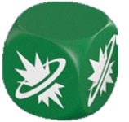

Setup

Player Setup

1. Player mat: Gain 1 player mat and place it in front of you. Slide all action tiles to the bottom and set all dials to their starting space.
2. Playing pieces: Gain the flags and player tokens of your colour and place them next to your player mat. Place 1 of your player tokens on each of the 0 spaces of the equipment on your player mat. Place 1 player torment on the 0 space of the experience track on the board.
3. Trackers: Gain 1 stamina tracker and stamina level tracker and place them on the 5 space of the track on your player mat.
4. Character: place your character in the continent you are currently in (in real life).

Global Setup

1. Board: Place the board in the middle of the table. Make sure there is space nearby for discard piles for each card type.
2. Cards: Shuffle all decks and place them on their designated spaces on the game board. Place the A mountain deck on the left mountain deck space and the B mountain deck on the right of the 2 mountain deck spaces. Deal 3 A mountain cards face up to the display.

Select a starting player. Play will proceed clockwise, with players choosing 1 action on their turn, placing a player token on it, and executing it.

The game ends at the end of a turn when you have placed all 18 of your flags on the board.

Gameplay

There are 3 actions to choose from on your turn: rest, prepare, and climb.

The basic actions are presented below, but it is possible to upgrade these actions with an upgrade reward (see *Rewards*).

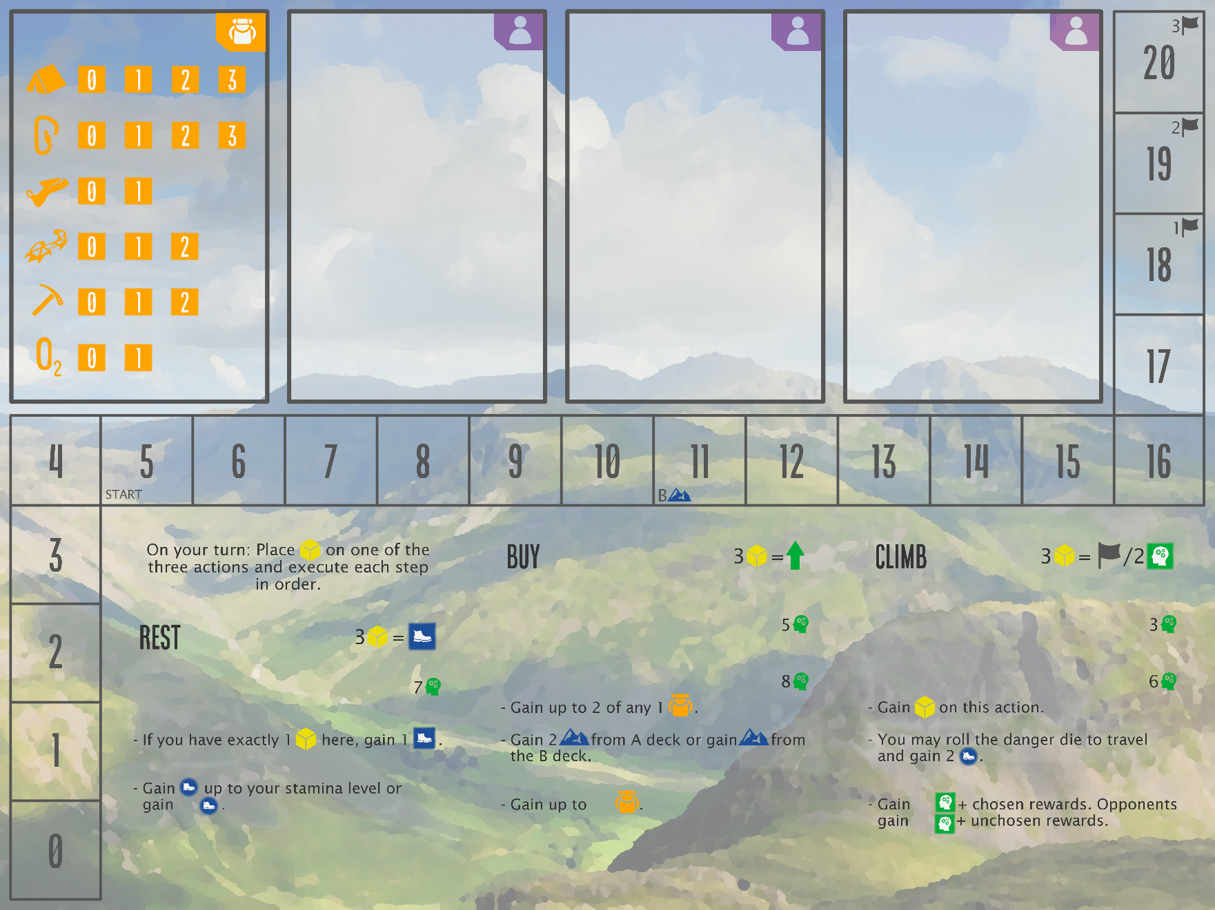

*Place a player token on this action.*

*Move your character to a different continent or keep it in the same continent it is in.*

*Move your stamina tracker to the*

Rest

When you choose to do the “rest” action on your turn, place a player token on it and do the following:

1. Travel

When you travel, move your character from your current position to any continent on the board. You may stay in the continent you are in.

2. Gain stamina up to your stamina level or gain 2 stamina.

Move your stamina tracker to the same space as your stamina level tracker on the track on your player mat. Instead, you may move your stamina tracker up 2 spaces.

Prepare

When you choose to do the “prepare” action on your turn, place a player token on it and do the following:

1. Gain 1 mountain.

Gain 1 mountain from the face-up display or from the top of a mountain deck of your choice.

Mountain cards are public – place them face up on the table next to your player mat when you gain them.

2. Discard the leftmost mountain (if any).

Discard the mountain in the leftmost slot of the display if it hasn’t been taken.

3. Gain up to 0 equipment.

Equipment is a requirement of climbing some mountains that you can’t just hike up. At the beginning of the game you won’t gain equipment, but it is possible to start gaining equipment by gaining an upgrade reward (see *Rewards*).

When you gain equipment, move 1 of your player tokens on equipment on your player mat to the right 1 space. This means you have 1 more of that equipment.

At the end of any of your turns, if there are empty spaces in the mountain display, slide all cards to the left and replenish the empty spaces with cards from the deck that is directly to the right of the display. The “A” mountain deck is directly to the right of the display at the start of the game. This changes to the “B” deck when any player’s stamina level gets to 11.

Companions

Companions help you climb mountains by adding to the overall experience requirement and giving you an ability if you use them when you climb or tag along on another player’s climb.

Companions are gained as rewards (see *Rewards*). When you gain a companion, place it on your player mat on an empty space with a icon and place a player token on its highest use number. If there are no empty spaces on your player mat, you may either discard it, or replace an existing companion, discarding the replaced companion.

To gain access to a companion’s ability and experience on a climb, reduce its use number by 1, by sliding down the player token on it 1 space. If the use number of any of your companions is to be reduced to 0, instead discard it.

Climb

When you choose to do the “climb” action on your turn, place a player token on it and do the following:

1. Choose 1 of your mountains and either its left or right rewards.

Each mountain card has 2 groups of rewards at the bottom. You will gain the chosen group of rewards if you successfully climb the mountain.



2. You and opponents who decide to tag along travel and pay requirements.

Opponents may join in on your climbs too! Only opponents who can and will pay requirements as well as the player whose turn it is may tag along. There are up to 4 types of requirements on each mountain to satisfy in order to climb a mountain.

Requirements

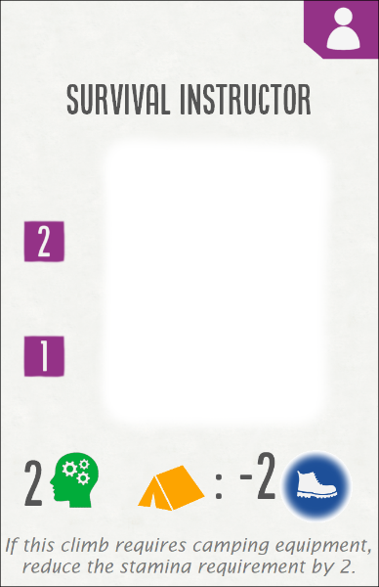

Experience: This requirement is satisfied together by all players on the climb rather than individually. Your experience, the experience of any opponents tagging along and the experience of each companion (yours or your opponents’) on this climb count towards the experience requirement.

If you do not collectively meet the experience requirement, you may still climb the mountain - but there’s a risk! Roll the danger die once for each experience you are below the requirement. If any roll results in [:(], you and any players tagging along may not gain any of the rewards underlined in green.

Stamina: You must pay the entire stamina cost specified to satisfy this requirement. To pay a stamina cost, reduce your stamina tracker by that many spaces on your player mat.

Equipment: To satisfy this requirement, for each equipment type on the mountain card, you must reduce each of the corresponding equipment on your player mat by 1.



Use number



Acclimatisation: You must not have travelled this turn to satisfy this requirement. Therefore, you may only climb mountains with this requirement if you were already in the right continent at the start of your turn (and opponents may only tag along if they were too!).



Experience

Ability

3. Gain 1 experience level and chosen rewards (opponents gain 1 experience level and unchosen rewards).

Gain the rewards on the side of the mountain card chosen at the start of this turn and any opponents who tagged along on the climb gain the rewards of the unchosen side. All players who climbed the mountain gain 1 experience. You (and opponents) may only gain rewards underlined in green if you did not roll any [:(] faces this turn. There are 6 types of rewards you can gain from climbing a mountain.

Each ability is explained on its card. You can still bring a companion on a climb even if you can’t use its ability. There is no limit to the number of companions brought on a climb.

Rewards



Flag: Place a flag from your supply in your current continent.

Stamina level: Move your stamina level tracker on your player mat up 1 space. As indicated on your player mat, if you are the first player to get to 11 stamina level, swap over the “A” and “B” mountain decks on the game board so that the “B” deck is on the left.



Bonus card: Draw a bonus card. Bonus cards give a boost to your endgame score by increasing your flag total if you fulfil the requirement. You may instead discard them during the game to gain a smaller bonus as noted on each card.

Upgrade: Gain the specified number of action upgrades. There are two ways to upgrade an action: slide up an action tile or rotate an action dial.

If you choose to rotate an action dial, choose 1 of the 3 actions and rotate its dial 1 space clockwise. Each time you take this action from now on, the final step will be slightly improved.

Instead, if you choose to slide up an action tile, you must first meet the experience prerequisite, which is the visible number above the tile you wish to upgrade. You must have at least this much experience to upgrade the tile. Slide 1 tile up as far as it can go, covering up the old experience prerequisite and revealing a new one if the action can be upgraded again. Each time you take this action from now on, you will take 1 extra step. You must take each step of an action in order.





Experience level: Increase your experience tracker on the board by the specified number of spaces. The number on the space where your tracker is is the amount of experience you have.



Companion: Draw a companion card (See *Companions)*.

Action Bonuses

When you choose an action on your turn, you place a player token on it. At any time on your turn, (even before you execute the action,) if you have at least 3 player tokens on an action, you may remove all player tokens from **all** 3 actions to gain the action bonus listed in the top right corner of that action:

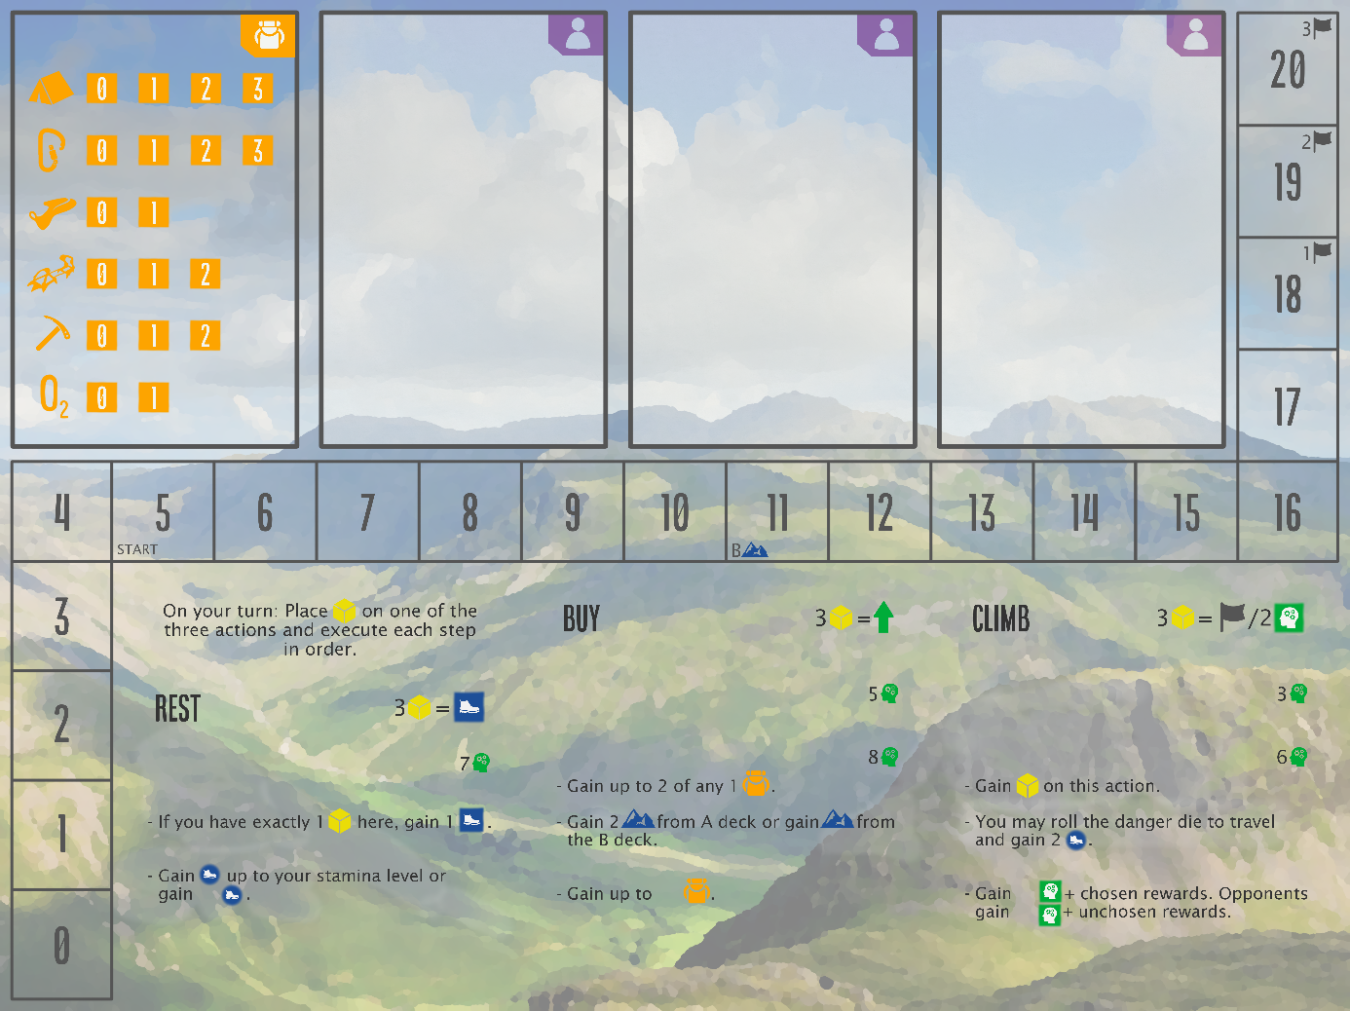

If you have at least 3 player tokens on the “buy” action, gain 1 upgrade.

If you have at least 3 player tokens on the “rest” action, gain 1 stamina level.

If you have at least 3 player tokens on the “climb” action, gain 2 experience level or place 1 flag in your current continent.



Game End

Count the total number of your flags (and player tokens) in all of the continents and add the number of flags depicted on your revealed bonus cards. The player with the highest total wins!

If case of a tie, use the following as tie breakers:

1. Highest stamina level

2. Highest experience

3. Turn order (from current player)

The game ends at the end of a turn when a player places their 18th flag. If you would place more than 18 flags, use player tokens as a substitute. Then all players simultaneously perform the following steps:

1. Reveal all of your bonus cards that have a fulfilled requirement.

2. Place 1 flag (or a player token if you’ve run out) in each continent in which you have more flags than each of your opponents (ties don’t count).

3. Place 3 flags in any continent if you have at least 1 flag in every continent.

4. Place flags in any continent for:

* Experience track
* Stamina level track
* Max upgrades

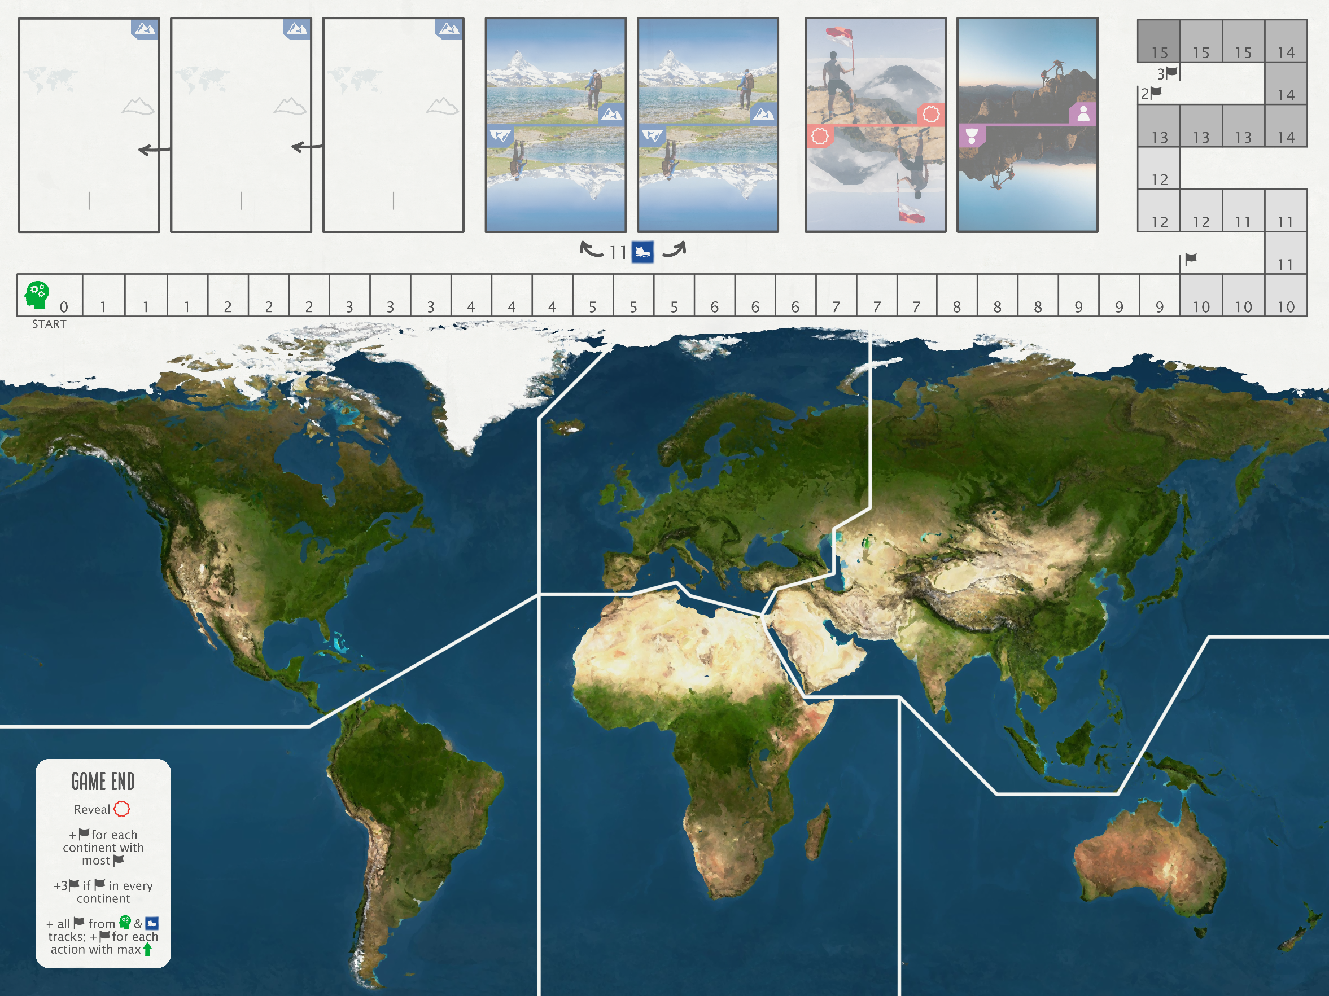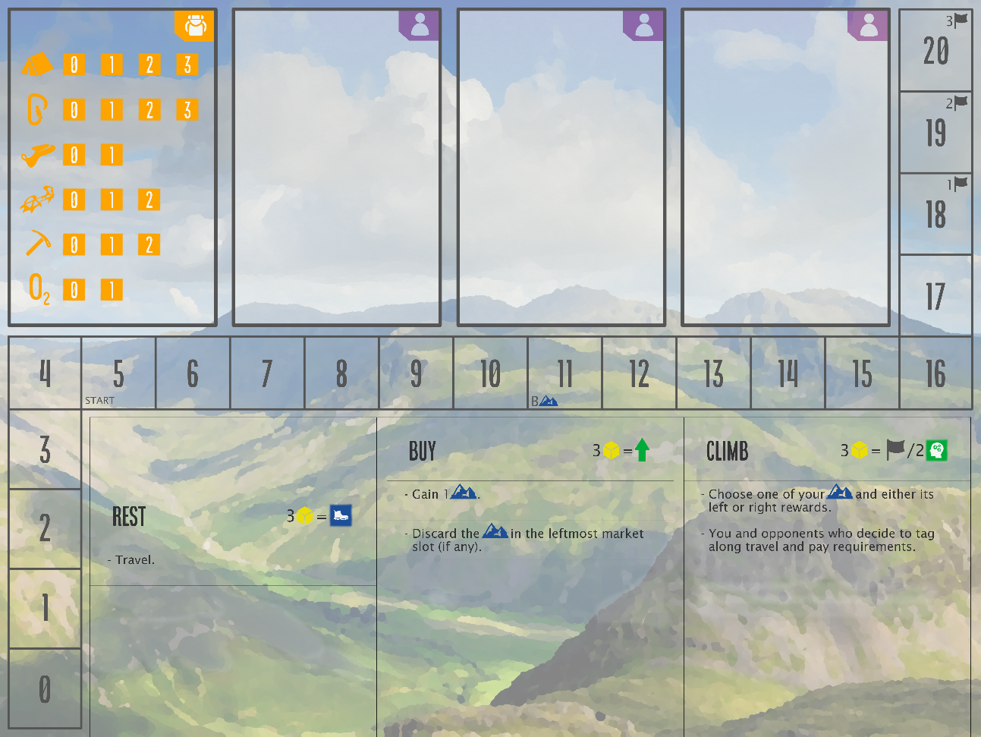

Negotiation: You may negotiate whether you will tag along or bring guides on a climb. You may even agree to pay part of an opponent’s equipment requirement to encourage them to tag along on one of your climbs on that turn. Any agreements are binding for that turn only.

Rewards and bonuses: Everything you gain is optional. When multiple things are gained, you may gain them in any order you wish.

Component limitations: player tokens and flags are not component limited. You cannot have more stamina, stamina level, equipment, or experience level than the numbers indicated on your mat/the board.

Other Important Notes